A000- Tchokwe, Angola, Cihongo mask of elderly man of noble rank-late 19th c

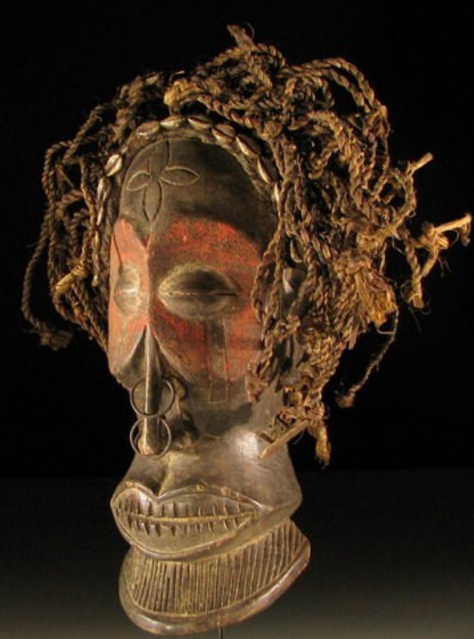 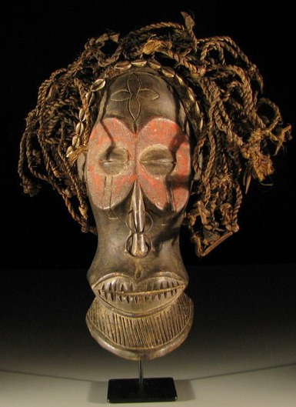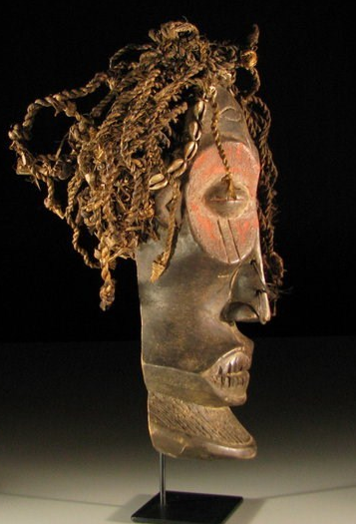

Tchokwe, Angola, Cihongo mask of elderly man of noble rank-late 19th c

Case No.:

**Accession No.**

**Formal Label:** Tchokwe, Angola, Cihongo mask of elderly man of noble rank-late 19th c

**Display Description:**

Tchokwe, Angola, Cihongo mask depicting an elderly man of noble rank with tribal tattoos, cowries symbolizing his lineage, metal rings symbolizing prosperity, and "hair" symbolizing virility made from plant fibers.

This mask is the most powerful and important Tchokwe mask and is known as *Cihongo* or *Cihunga*. Highly charged with power and considered sacred, *Cihongo*  is used during investiture ceremonies of a chief and sacrifices to the ancestors. Gaunt features, sunken cheeks, and jutting beard of an elder characterize a *chihongo* mask. *Chihongo* was formerly worn only by a chief or by one of his sons as they traveled through their realm exacting tribute in exchange for the protection that the spirit masks gave. These masks are made in two ways. One is of barkcloth stretched over an armature of wickerwork, covered over with black resin and painted with red and white designs. The other is an elaborate wooden mask painted with red around the eyes. *Cihongo*  is worn only by the current chief of a group. Paired with the *Ciihongo* mask, is the *Pwo* mask, Cihongo's consort. While *chihongo* brings prosperity, his female counterpart, *pwo*, is an archetype of womanhood, an ancestral female personage who encourages fertility. As an ancestor, she is envisioned as an elderly woman. The eyes closed to narrow slits evoke those of a deceased person. The facial decoration on the surface are considered female. Recently, *Pwo* has been transformed into *mwana pwo*, young woman. It represents a young woman who has undergone menstruation rites and is ready for marriage.

**LC Classification:**

**Date or Time Horizon:**

**Geographical Area:**

**Map:**

**GPS coordinates:**

**Cultural Affiliation:**

**Media:**

**Dimensions:** H  46 cm

**Weight:**

**Condition:**

**Provenance:**

**Discussion:**

One million Tchokwe (Kocokwe, plural Tucokwe) have migrated over a wide area in eastern Angola, southern Dem. Rep. of Congo and Zambia. Their recent history dates back to the 15th century, when a Lunda queen married a Luba prince Chibinda Ilunga. A significant member of the Lunda aristocracy so disapproved of the marriage that they migrated south to present-day Angola. Once settled, they founded several kingdoms, each headed by a god-king. Around 1860, following a major famine, the Tchokwe people migrated to the source of the Kwangi, Kasai and Lungwe rivers where there was enough water for their herds and farming. The Tchokwe are governed by a king called Mwana Ngana, who distributes hunting and cultivation areas. The male Mugonge and female Ukule societies regulate their social life. They are vigorous and courageous hunters and agriculturists, who used formerly to engage in the slave trade. Their dynamic spirit is also reflected in their art.

Tchokwe sculptors were the most famous of the region and were comprised of two types: the *songi* and the *fuli.* The songi made folk art including *jinga* charms, small *mahamba* figures for the family shrines, and charms used in hunting, love magic, and fertility. The *fuli were* professional court artists who were hired by the great chieftaincies and worked exclusively for the court. It was a *fuli* who sculpted this Cihongo mask for a revered elder. In addition *fuli* sculpted scepters, thrones with figurines, fans, tobacco boxes, pipes, flyswats, cups, and figures of chiefs or ancestors and large statues of deified ancestors, exalting strength and dignity. The best-known representation of a chief is of Chibinda Ilunga. He was a wandering hunter, youngest son of the great Luba chief Kalala Ilunga. He married a Lunda queen Lueji. Chibinda Ilunga was the start of the sacred dynasty of the Mwata Yamvo of the Lunda and became the model of the hunting and civilizing hero, sometimes represented seated on a throne, sometimes as standing naked or dressed as a hunter. As statues of him were sculpted after the introduction of firearms, generally the standing figure is holding a stone rifle in his left hand and a stick, called *cisokolu*, in his right. Chibinda Ilunga’s body is stocky, with legs bent, shoulder blades clearly drawn, the neck wide and powerful, the navel protruding. He wears an enormous hairdo, the sign of princely rank. The social organization, founded upon matrilineal lineages, has an equally large number of female statues, whether these be identified as the queen mother or a chief’s wife.

**References:**

**Appendix:**

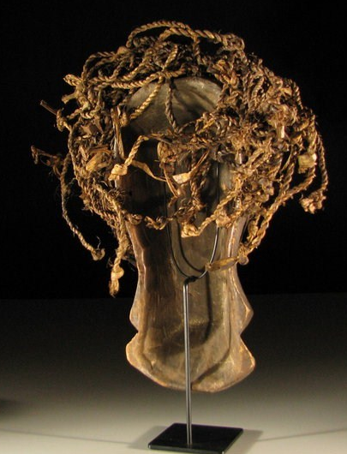

**ed**